Project Development Phase
Model Performance Test

Date | 19 February 2026
Team ID | LTVIP2026TMIDS47881
Project Name | ShopEZ:One -Step Shop For Online Purchases
Maximum Marks | 10 Marks

Model Performance Testing:
Project team shall fill the following information in model performance testing template.
S.No. | Parameter | Values | Screenshot
 | Metrics | Regression Model:  MAE – 2.1, MSE -5.8 , RMSE – 2.41, R2 score -0.87  Classification Model:  Confusion Matrix - , Accuray Score- & Classification Report - | 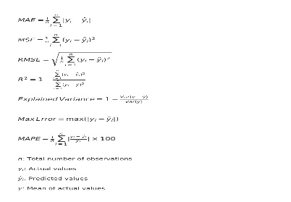
 | Tune the Model | Hyperparameter Tuning -  Validation Method - | 